Flowers Central

PRESS RELEASE

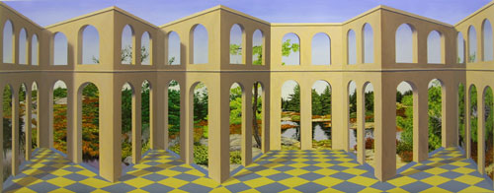

PATRICK HUGHES

1st to 11th September
Private view Wednesday 1st September

For the first two weeks in September, Flowers Central are proud to present a group of monumental new works by Patrick Hughes.

An important British Pop Artist and Surrealist from the 1960s and 1970s, Hughes is familiar to many for his evocative series of works incorporating a ‘rainbow’ as an artistic motif. More recently, he has been concentrating on false-perspective and the art of illusion to create images that appear to recess into the picture plane, but on closer inspection actually project into the viewer’s space. Paintings that at first glance appear to be two-dimensional depictions, seem to move with you as you walk past, making corridors and arches come in and out of view, doors and shutters open and close, and give the illusion that one can see round corners. Adapting this extraordinary technique with reverence to Paul Klee, and particularly the Surrealist René Magritte, Patrick Hughes has developed a truly unique surrealist art-form.

For further information, please contact Francis Burrows or James Ulph at Flowers Central on 020 7439 7766 or email central@flowerseast.com

Flowers Central
21 Cork Street
London
W1S 3LZ
www.flowerseast.com

