FLOWERS EAST

PRESS RELEASE

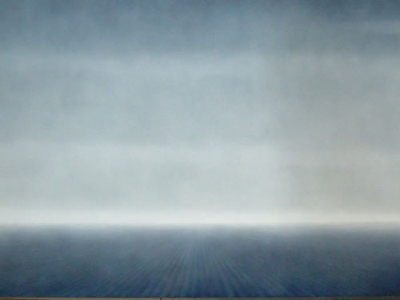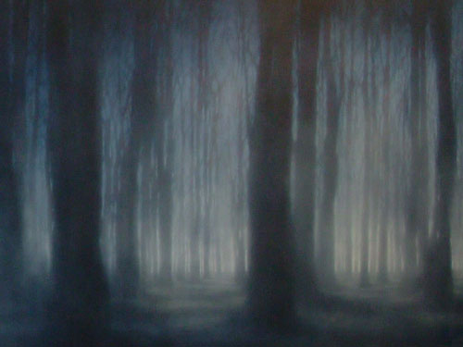

Clear Field and Dark Wood 2004 198 x 304 cm / 78 x 119½ in each panel

KEN CURRIE NEW WORKS

16 September – 16 October 2005
Private view Thursday 15th September 2005
Opening times: Tuesday to Saturday 10am until 6pm, Sunday 11am until 5pm

Flowers East presents new work by the eminent Glasgow-based painter Ken Currie. This new body of work covers a period from 2003-2005 and encompasses a variety of themes and imagery explored in works both on canvas and paper. Often on a large-scale, the works concentrate mainly on the human figure but also contain images where the absence of the human presence is emphasised. New territory for Currie is also explored in the form of landscape.

In a number of works there is contemplation on the complexities and contingencies of the process of ageing, of loss and the passing of time, as well as a new emphasis on simple painterly elements such as light and space and the power they have for imaginative suggestion.

In other works there is an engagement with the physical reality of our mortality, be it through natural processes or as a result of political violence, that attempts to highlight the sheer vulnerability of the human situation.

In the diptych ‘Clear Field and Dark Wood’, there is a visual meditation on the Russian proverb: “We are born in a clear field and die in a dark wood”. The open possibilities of birth are contrasted with the encroaching complexities and doubts of old age.

In this challenging exhibition “Currie invites us, in imagination at least, to step beyond our mortal limits and venture into the darkness of the unknown”. Currie is one of the most powerful and evocative artists of our time; this is an exhibition not to be missed.

The next exhibition at Flowers East will be ‘Edward Burtynsky: New China Works’ running from the 20th October to the 20th November 2005.

For further information, please contact Cate Rickards on 020 7920 7777 or cate@flowerseast.com

Flowers East
82 Kingsland Road
London E2 8DP
www.flowerseast.com

