PRESS RELEASE

FLOWERS EAST
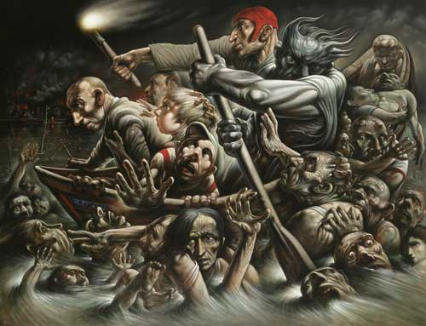
Peter Howson, Acheron 2005, oil on canvas

PETER HOWSON:

Acheron & Other Works
24 November – 15 January 2006
Private view: Wednesday 23rd November, 6-8pm
Opening hours: Tuesday to Saturday 10am until 6pm, Sunday 11am until 5pm

The new Peter Howson exhibition at Flowers East, following on from ‘Stations of the Cross’ 2003 and ‘Christos Aneste’ 2005, contains brilliant and astonishing new work by this eminent Scottish artist. He continues to focus on the religious themes that have inspired a series of deeply moving and important works. In this exhibition, exquisitely detailed and sensitive drawings are set alongside large-scale paintings, which possess all the boldness and power for which this artist is renowned.

Howson is deeply conscious of the great tradition of painting and of the undimmed relevance of past masters to the present-day artist – and public. Like his artistic heroes, Howson imbues his work with spiritual power, whether he is darkly portraying the suffering of his subjects or rejoicing in their salvation. This is the great tradition expressed anew with a unique and truly contemporary aesthetic.

Although his work emphasises the emotions of sorrow and anguish, Howson never loses hope in the triumph of the human spirit. The painting Acheron 2005 (illustrated above) epitomises the dynamism and energy that are characteristic of his latest work. Amid noise and chaos, fearful souls desperately clamber up and tear at the crowded vessel. As this grim boat forges ahead, the passengers remain massively intent on reaching their destination - the underworld.

Howson’s masterful use of chiaroscuro contrasts intense bursts of light with the otherwise sombre colouring, and adds to the overall drama. He also brings a powerful visual rhythm to the composition; Howson confidently masters an ambitious and complex arrangement of figures, creating an underlying order and harmony that gives the work its ultimate beauty.

The next exhibition at Flowers East will be ‘Patrick Hughes: Permanentspective’, running from the 20th January to the 19th February 2006.

For further information, please contact Ben Lawrence at Flowers East on 020 7920 7777 or email ben@flowerseast.com

Flowers East
82 Kingsland Rd
London
E2 8DP
www.flowerseast.com

