PRESS RELEASE

FLOWERS CENTRAL

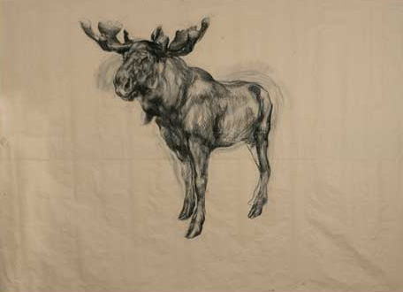

NICOLA HICKS: DRAWINGS

11 January – 4 February 2006
Private View: Tuesday 10th January 2006
Opening Times: Monday to Saturday 10 am until 6pm

Nicola Hicks, one of Britain’s leading contemporary sculptors, presents new drawings in this forthcoming exhibition at Flowers Central. Nicola was born in London in 1960; she studied at Chelsea School of Art, followed by an MA at the Royal College of Art. She has had several major solo shows in leading museums and galleries in Britain, most recently at the Abbot Hall Gallery in Kendal.

Drawings stand apart in art history, often as fascinating expressions of an artist’s first ideas. The spontaneity with which the line is released onto the page reveals unique responses that are perhaps less evident in a finished painting or sculpture. Nicola Hicks’ charcoal drawings have a vigour and immediacy that express the focus and energy that she injects into all her work. She views her drawing as a process that runs parallel with her sculpture; the two are inseparable, one feeds and inspires the other. Nicola explained that ‘thought flows very freely onto paper via a piece of charcoal…so ideas pour out very directly...’

Five years ago, Nicola moved out of London to live in the country, where she has continued to develop the power and beauty of her work. Perhaps it is no coincidence that in this exhibition animals are her focus. Nicola goes further than to simply depict her subjects; she deeply explores the psychology of her creatures. ‘Nicola Hicks starts from the reality of figures and animals, and captures the living truth of them with extraordinary vividness…’ (Norbert Lynton)

The next exhibition at Flowers Central will be new paintings by Renny Tait, running from the 7th February to the 4th March 2006.

For further information, please contact James Ulph or Di Poole on 020 7439 7766 or email central@flowerseast.com

Flowers Central
21 Cork Street
London
W1S 3LZ
www.flowerseast.com

