Flowers Central
PRESS RELEASE

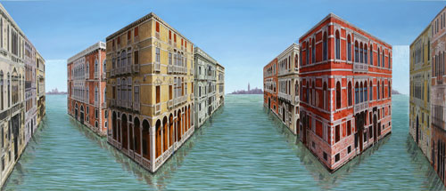

PATRICK HUGHES

GRAND CANALS

10 January – 3 February
Private view: Tuesday 9 January 6pm – 8pm
Opening Times: Monday – Friday 10am until 6pm, Saturday 10am until 2pm

Flowers Central starts the year with a spectacular show of new paintings by Patrick Hughes. The exhibition focuses on the city of Venice, one of the artist’s most striking themes. Following on from the highly praised show, Permanentspective, in January 2006, Hughes uses the unique imagery of this floating city to further investigate the celebrated powers of his ‘reverse perspective’.

The three-dimensional images challenge perceptions of reality. They raise and illuminate puzzling questions about the nature of art and representation. Just as the Cubism of Picasso and Braque aimed ‘to get rid of trompe l’oeil and to find a trompe l’esprit, Hughes questions the workings of the mind and the habitual certainties of the viewer. The techniques of reverse perspective present the world the ‘wrong’ way round; the viewer is forced to see the picture as going in where it protrudes and vice versa. Closer inspection reveals the mechanics of the illusion; yet even with this in mind the viewer’s eyes cannot stop the visual magic from working. The fascination in this work lies in the revelation that the mind cannot necessarily see what it ‘knows’ to be true.

Reflection and colour, and the brilliant use of shadow and variation of pictorial depth, are employed to startling effect in this show - as demonstrated in Cast of Shadows, 2006, shown above. The canals and intricate Venetian buildings, leading to the stunning vistas beyond, provide the perfect imagery for masterful illusions, which in truth are no more illusory than supposed reality itself.

The next exhibition at Flowers Central will be Eduardo Paolozzi, running from the 7 February until the 3 March 2007. For further information, please contact Di Poole or Tanya Coia on 020 7439 7766 or email central@flowerseast.com

Flowers Central
21 Cork St
London
W1S 3LZ
www.flowerseast.com

