press release  RICHARD SMITH  Private view: 14 March 2008, 6-8 pm  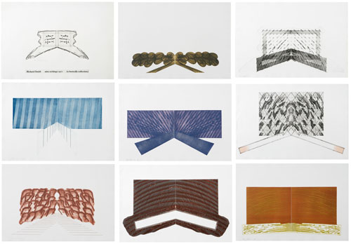  15 March – 12 April 2008  Opening times: Tue-Sat 10-6 | 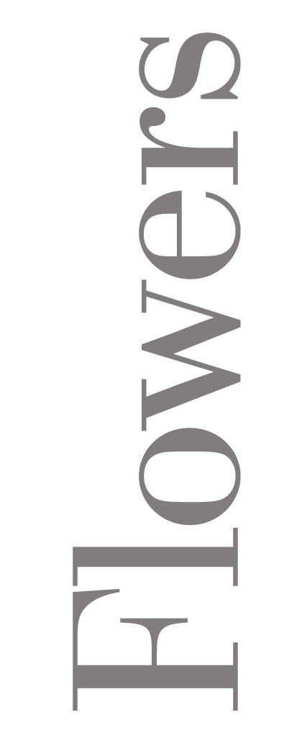  82 Kingsland Rd  London  E2 8DP

Richard Smith, born in 1931, is a member of the brigade of artists who created the post-war renaissance of British art - a movement now attracting much increased and deserved attention. Smith, a contemporary of Peter Blake and Joe Tilson at the Royal College of Art, was also strongly influenced by developments in the US, where he has lived and worked for long periods of time.

Pop Art was a major influence, but Smith’s work has always leant towards abstraction, which became dominant as the years went on. His swings of artistic mood and subject matter required an equally experimental reception by his audience.

The paintings on show at Flowers East are a fine example of Smith’s originality. They date from 1970-71, and, as the artist explains, ‘are the last of the three-dimensional paintings that were started in 1962-63. They are called the Butterfly Paintings because some have these double planks coming out from the bottom centre. The supports were made by an excellent carpentry firm in Bath. They are, however, very heavy, and that encouraged me to change to the light Kite format that occupied me for the next decade or so’.
Originally shown at the Museum of Modern Art in Oxford in 1972, this is the first time these remarkable works have been seen for over 30 years. They are essential viewing for anyone who wants to follow the evolution of British art and its gifted creators.

For further information, please contact Ellie Harrison-Read at Flowers East on 020 7920 7777 or email gallery@flowerseast.com.

Flowers East 82 Kingsland Road London E2 8DP www.flowerseast.com

