press release  NICOLA HICKS  CIRCUS  Private view: 23 June 2008  6-8pm  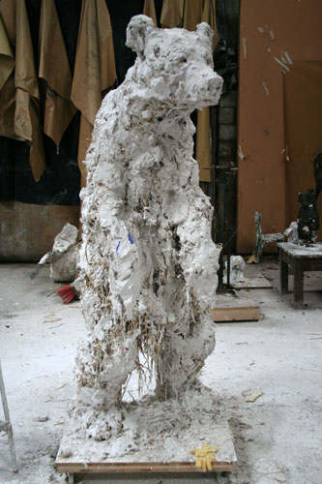  Opening times: Mon-Fri 10-6, Sat 10-2 | 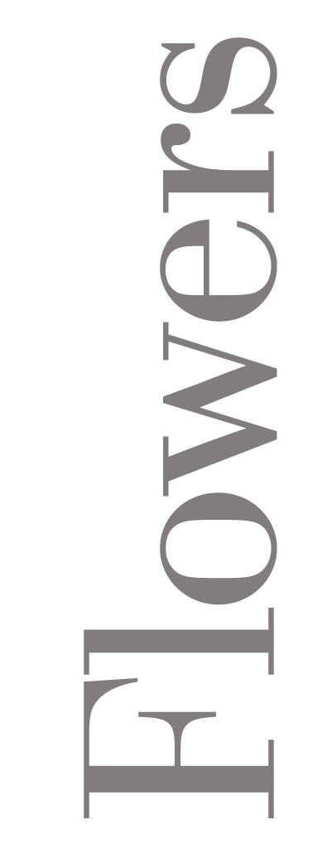  21 Cork St  London  W1S 3LZ

Nicola Hicks, one of Britain’s leading contemporary sculptors, presents new sculptures and maquettes in this forthcoming exhibition at Flowers Central. Nicola was born in London in 1960; she studied at Chelsea School of Art, followed by an MA at the Royal College of Art. She has had several major solo shows in leading museums and galleries in Britain, most recently at the prestigious Abbot Hall Gallery in Kendal.

In 2001, Hicks moved out of London to live in the country, where she has continued to develop the power and beauty of her work. It is perhaps no coincidence that animals have increasingly become her focus. Nicola goes further than to simply depict her subjects; she deeply explores the psychology of her creatures. ‘Nicola Hicks starts from the reality of figures and animals, and captures the living truth of them with extraordinary vividness…’ (Norbert Lynton)

In her new rural surrounds, Hicks was faced with the formidable task of producing art ‘amidst the outrageous beauty of nature’. The result, as shown by this exceptional selection of sculptures, is a body of work imbued with the energy and vitality of ‘the thumping landscape’ in which it was engendered. She delights in the physical and personal act of making things, injecting an immediacy and vigour into the work.

For further information and images please contact Sophie Hall or James Ulph
on 020 7439 7766 or email central@flowerseast.com.

Flowers Central 21 Cork St London W1S 3LZ T: 020 7439 7766 www.flowerseast.com

