press release  PATRICK HUGHES  PERSPECTIVIRTUOSO  Private View: SATURDAY 20 SEPT 2008, 2-4 pm  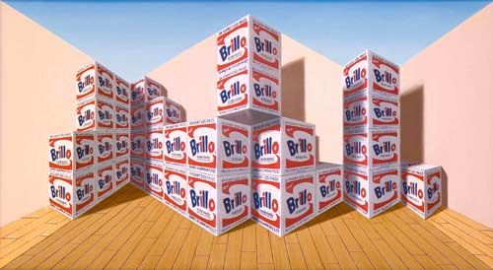  19 September – 18 October 2008  Opening times: Tue-Sat 10-6 | 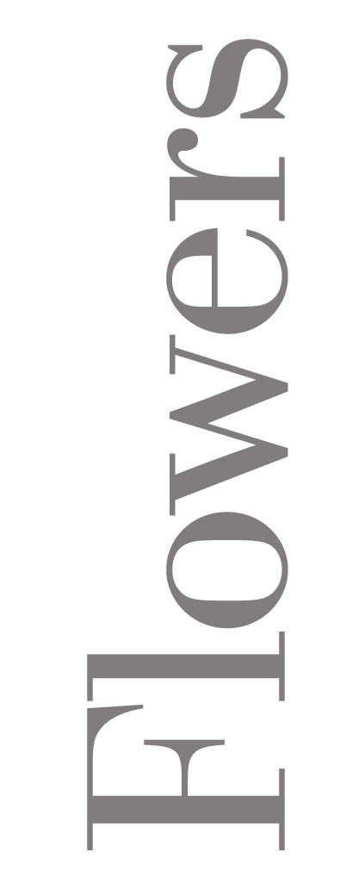  82 Kingsland Rd  London  E2 8DP

Entering a room of Patrick Hughes' reverse perspective paintings is an overwhelming experience. Horizons thrust themselves forward. Vanishing points jut out when they should recede. It is visual anarchy. All the normal rules of perception are broken and our senses are reeling. We are alone, striving to make sense of all this. Just exactly what is going on?

The artist Patrick Hughes has been making work of extraordinary diversity over the past forty years, confounding the expectations of his audience, by turns delighting and intriguing. He is the author of engaging and provocative books on paradox, puns and oxymoron but it is the sheer impact of standing before his vertiginous large paintings, experiencing these bewildering sensations that reminds us that his is a unique vision in the world of contemporary art.

These meditations on the nature of perception are not in any sense dry, academic theses. As striking visual compositions they positively abound with humour and remain both exhilarating and entertaining.

Glen Baxter reflects on the playful and perplexing panoramas of Patrick Hughes’ ever-expanding oeuvre in his introduction to Left to Write, a new book of collected writings by the artist.

Flowers East are celebrating Patrick Hughes 69th birthday and the launch of Left to Write with a solo show entitled Perspectivirtuoso; a body of astonishing new and recent three-dimensional paintings.

Patrick Hughes lives and works in London. His work is included in important public collections including the British Library, the Tate Gallery, London, the Gallery of Modern Art, Glasgow, the Denver Art Museum and the Nasher Museum of Art at Duke University, North Carolina. To date he has had over 100 solo shows world-wide.

A book launch and artist’s talk will take place on Saturday 18 October, 12 – 2pm.

For further information, images, or to order your copy of Left to Write please contact Amie Conway or Ellie Harrison Read at Flowers East on 020 7920 7777 or email gallery@flowerseast.com.

Flowers East 82 Kingsland Road London E2 8DP www.flowerseast.com

