press release  PETER HOWSON  HARROWING OF HELL  Private View: THURSDAY 23 OCT 2008, 6-8 PM  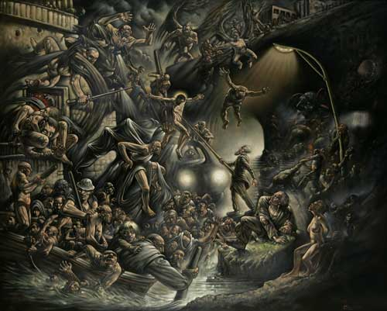  24 October – 22 November 2008  Opening times: Tue-Sat 10-6 |   82 Kingsland Rd  London  E2 8DP

Peter Howson is an artist of disarming visual honesty. His work, which at different stages in his career has celebrated allegory and allegorised celebrity, depicting the landscapes of modern war and internal struggle and with a Goyaesque brilliance, is testament to an obsessive occupation with the dark recesses of existence that developed into a muscular faith and spiritualism.

Howson is a compelling storyteller. The new works shown here – epic oils and dense hatchings of graphite on gesso – are not academic or didactic in the style of history painting, but the sublimation of revelatory personal narratives. Religious overtures are proceeded by confession, as intimate details of the artist’s familial and spiritual relationships punctuate the parables of his urban imagination. Howson describes the works as ‘autobiographical or semi-autobiographical’, pictorial evidence of the pain and turmoil resulting from his daughter Lucie’s struggles with epilepsy and Asperger’s Syndrome. He credits Lucie for saving him from a spiral of alcoholism, drug addiction, infidelity and obsessive behaviour; the destructive prelude to his conversion to Christianity in 2000. Howson reconciles the trauma of Lucie’s condition by seeing it as 'a faith test' and, as such, the works - whilst pregnant with grief and suffering - are not without hope or redemptive possibility.

Howson’s faith is a robustly tangible one. He is not a fan of rationalism, nor does he subscribe to the type of academic Enlightenment that brushes aside morality to further the cause of ‘civilised' scientific knowledge. He believes Truth comes from looking at the world in a childlike way, and his appreciation of a level of perceptional innocence is recognisable in the gargantuan figures – with their bulging, sinewy limbs, colossal feet and outsized noses – that populate his canvases. Though executed with mature painterly skill, the gigantism and physical crudeness of these characters hints at the childlike glint in the eye of their earthly creator.

Prior to converting to Christianity, Howson responded to pain by pursuing hedonism. His experiences of abuse – whether self-inflicted and substance-related or the traumatic events of his childhood - have afforded him an affinity with those individuals who are classed as somehow 'on the edge'. His work has caught the attention of a number of prominent cultural figures, celebrities and creatives as well as striking a chord with prisoners, a voiceless demographic from whom Howson receives many letters of support. His ability to speak to the peripheries – to both the exclusive echelons living ‘the high-life’ and the socially alienated outsiders labelled 'low lives' – is proof of his enduring skill at capturing the maverick, excessive and non-conformist, while also seeking spiritual change.

Peter Howson has exhibited with Flowers since the 1980s. He will soon embark on a dramatic rendering of the martyrdom of St John Ogilvie, to be placed in St Andrew’s Cathedral, Glasgow, when it re-opens after renovation works in 2010. This will be the biggest commission for a Scottish Catholic Cathedral since the 16th century.

For further information or images please contact Ellie Harrison-Read at Flowers East on 020 7920 7777 or email ellie@flowerseast.com.

Flowers East 82 Kingsland Road London E2 8DP www.flowerseast.com

