press release  GLENYS BARTON  DANCERS AND ANGELS  Private View Tuesday 3 February 6-8pm    4 – 28 February 2009  Opening times: Mon-Fri 10-6, Sat 10-2 | 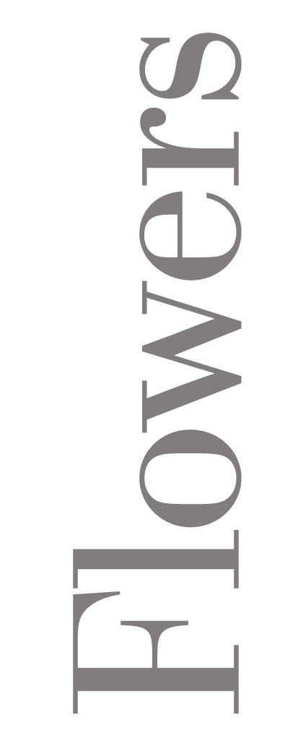  21 Cork St  London  W1S 3LZ
Glenys Barton first joined Angela Flowers Gallery in 1973 after graduating from the Royal College of Art. Since then she has had numerous solo shows with Flowers, and also notably at the National Portrait Gallery in London, Manchester City Art Gallery and in the town in which she was born, Stoke on Trent.

Her sculpture, largely in ceramic, is made with great attention to the surface quality of the clay and its colours, which range from smoky whites and pale blues that merge with a porcelain body to bright turquoise, contrasting with the red of terracotta. In recent bronze casts, Barton has chosen light patinas, close in nature to her work in porcelain.

The current body of work reflects a long-standing interest in both ‘dance’ and ‘angels’, and in particular the winged nature of the latter. Trained in contemporary dance in the early 60s, it has always informed her work, but it was not until a major commission for Hextable Dance in 2004 reintroduced her to the aesthetic that Barton began to explore this means of expression in more depth. The marriage in theme to ‘angels’ then became inevitable:

‘I started to notice them more and more: stone carvings and stained-glass windows in churches, religious paintings from the earliest times. Everywhere I looked I seemed to see Angels. How interesting the forms were: the shape of the wings, how the wings were used in the composition of the piece, around the form. How the wings could be used to support the rest of the form.’

Glenys Barton’s work also features in the screen adaptation of Ian McEwan’s ‘Enduring Love’ which starred Daniel Craig, Samantha Morton and Bill Nighy, sculpted portraits of whom she was commissioned to make for the film.

For further information and images, please contact Ellie Harrison-Read on 020 7920 7777 or email ellie@flowerseast.com.

Flowers 21 Cork St London W1S 3LZ T: 020 7439 7766 www.flowerseast.com

